DC1-Internal Data

WIZZ AIR
OPEN DAY FOR WIZZ AIR HUNGARY/WIZZ AIR MALTA

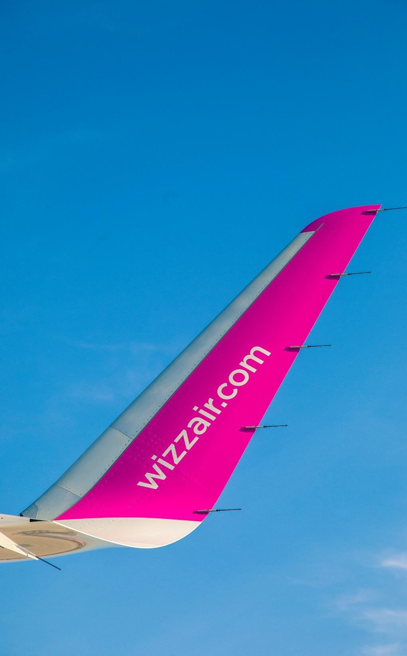
AGENDA
1
COMPANY INTRODUCTION
⇧ Business Model
⇧ WIZZ Bases
⇧ Fleet
2 TERMS AND CONDITIONS FOR PILOTS
⇧ Contracts
⇧ Salaries
⇧ Rosters
⇧ Base Change Policy
3
⇧ Benefits
HOW TO APPLY & RECRUITMENT PROCESS

4 Q&A
DC1-Internal Data

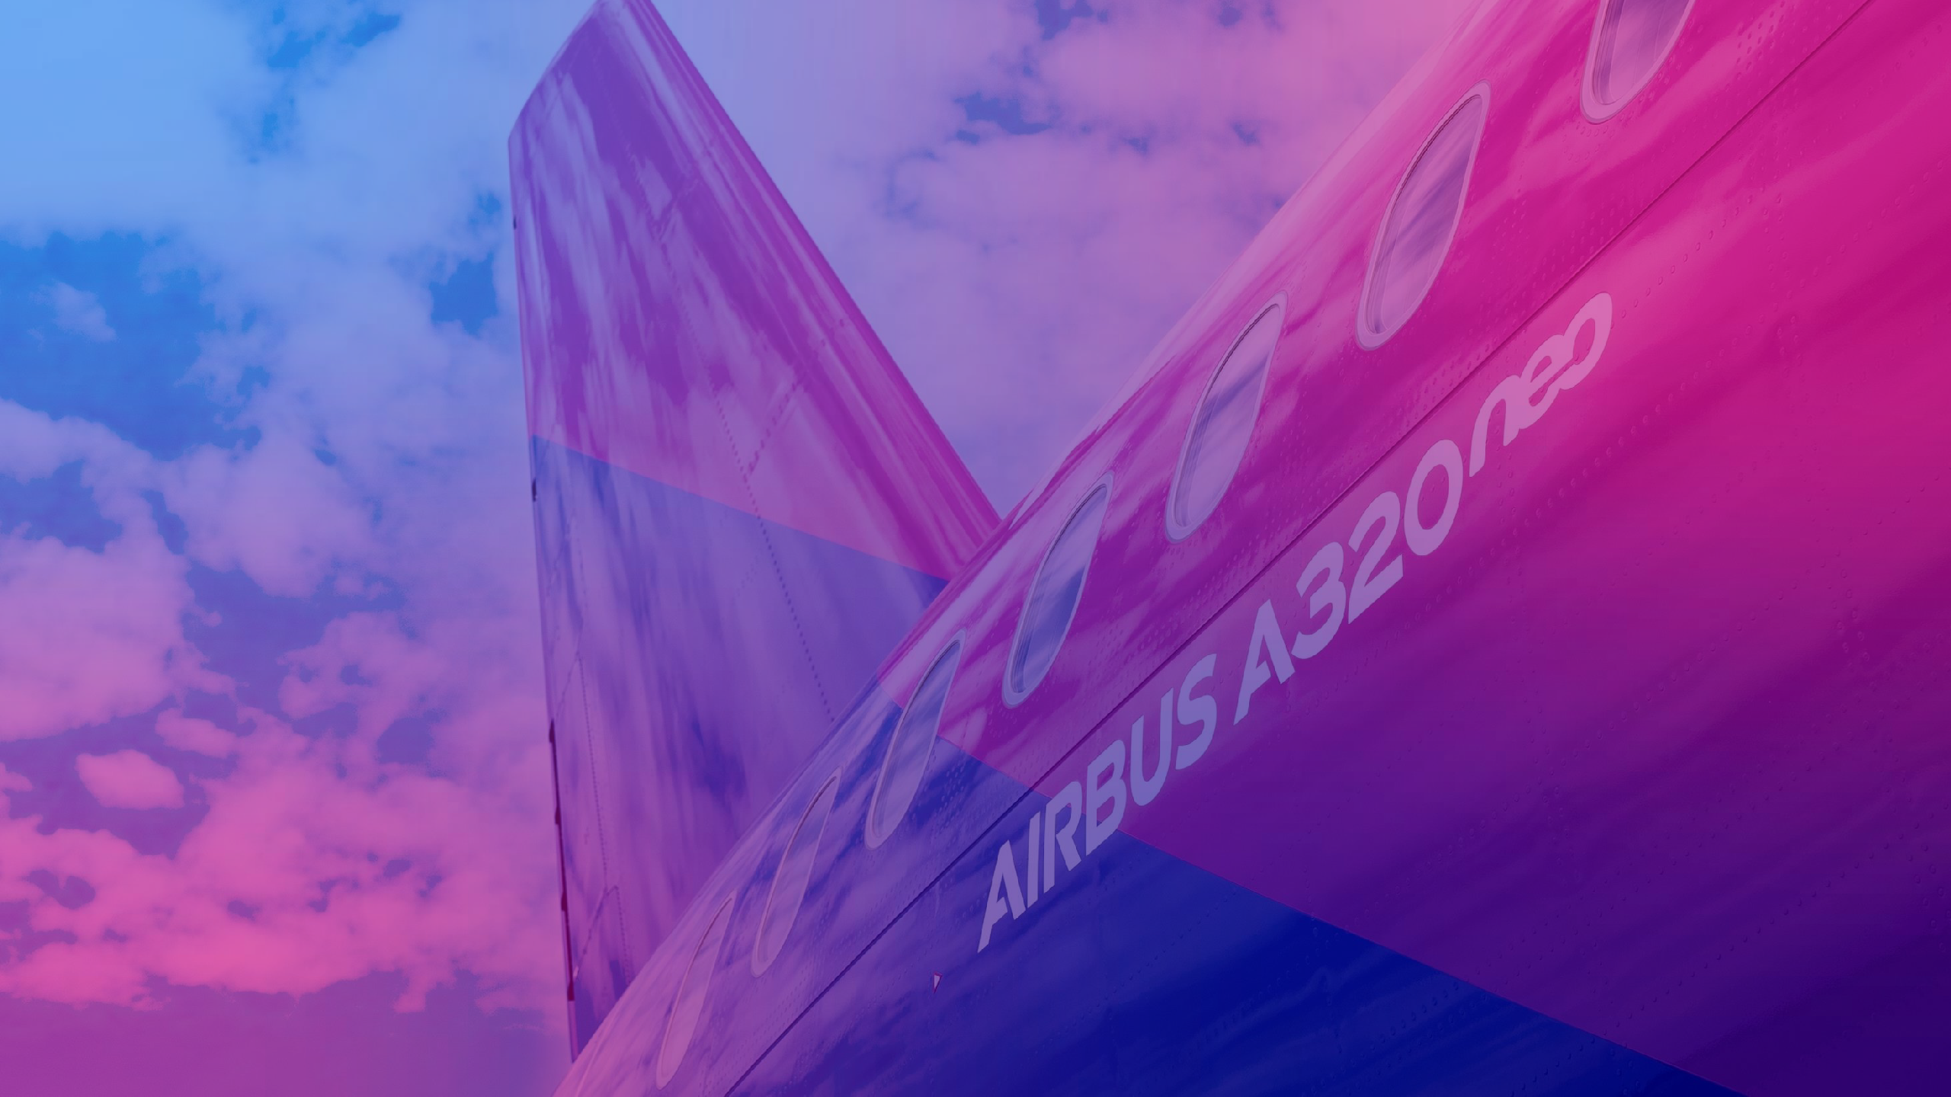

COMPANY INTRODUCTION

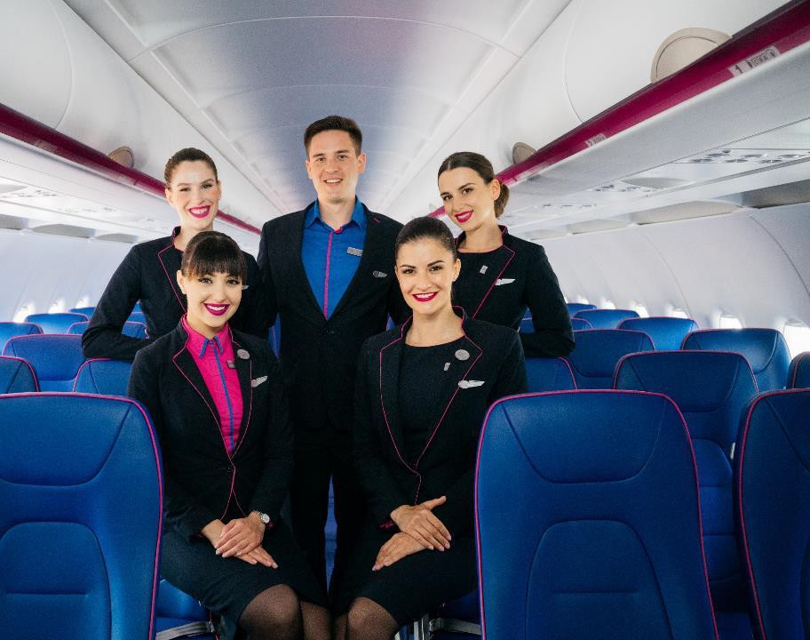
WHO WE ARE

We challenge ourselves daily to be the most loved ultra low-cost airline. Some might say that’s ambitious, but in 18 years we’ve defied the odds, becoming Europe’s fastest growing and greenest airline.

Continuing to connect people to the experiences, places and people that matter the most at the best price, is at the heart of the WIZZ brand.

We plan to more than triple the fleet to 500 aircraft by the end of the decade.

WIZZ AIR HAS BUILT A BIG BUSINESS AROUND A SIMPLE PURPOSE
“Liberating lives through affordable travel”.

DC1-Internal Data

WIZZ AIR TODAY

FLEET
- Airbus A320ceo, A321ceo, A320neo and A321neo
- Fleet growth +17% (FY23/22)
ROUTES ON SALE
- 950+ routes
- 200+ destinations
- 50+ countries
CARRIED PASSENGERS
45.6 million in CY22

STAFF
8000+
OPERATING BASES
32 bases in 15 countries

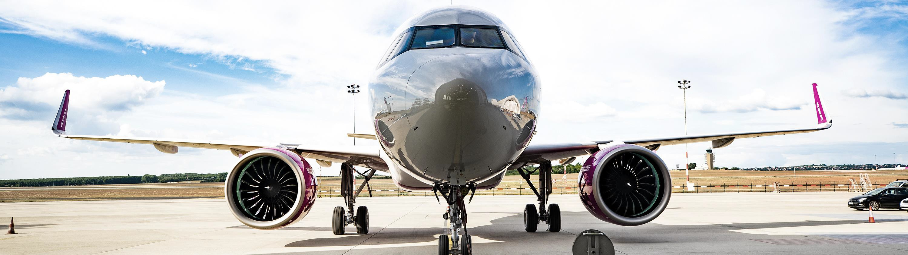

DC1-Internal Data

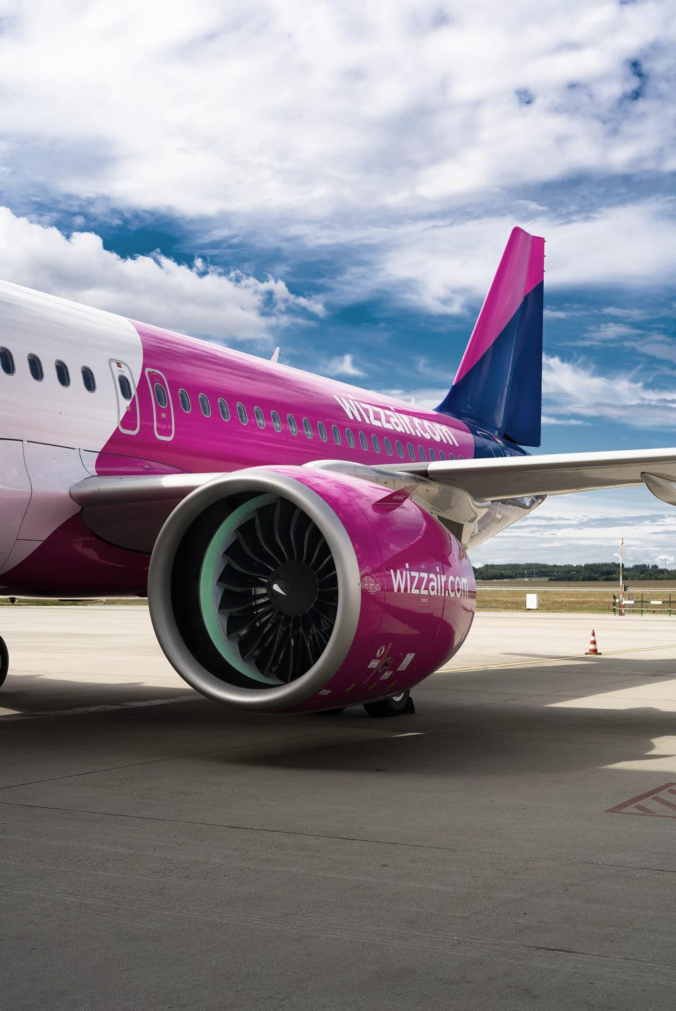
4 AIRLINES & 32 BASES
WIZZ AIR HUNGARY
BOSNIA & HERZEGOVINA Tuzla
BULGARIA Sofia, Varna
CYPRUS Larnaca
GEORGIA Kutaisi
HUNGARY Budapest, Debrecen
LITHUANIA Vilnius
NORTH-MACEDONIA Skopje
POLAND Katowice, Krakow, Warsaw, Gdansk, Wroclaw
SERBIA Belgrade

WIZZ AIR MALTA
ALBANIA Tirana
AUSTRIA Vienna
ITALY Rome FCO, Milan MXP, Catania, Naples, Venice
ROMANIA Bucharest, Cluj-Napoca, Craiova, Iasi, Sibiu, Suceava Timisoara
WIZZ AIR UK
UNITED KINGDOM London Luton, London Gatwick

WIZZ AIR ABU DHABI
UNITED ARAB EMIRATES Abu Dhabi

6

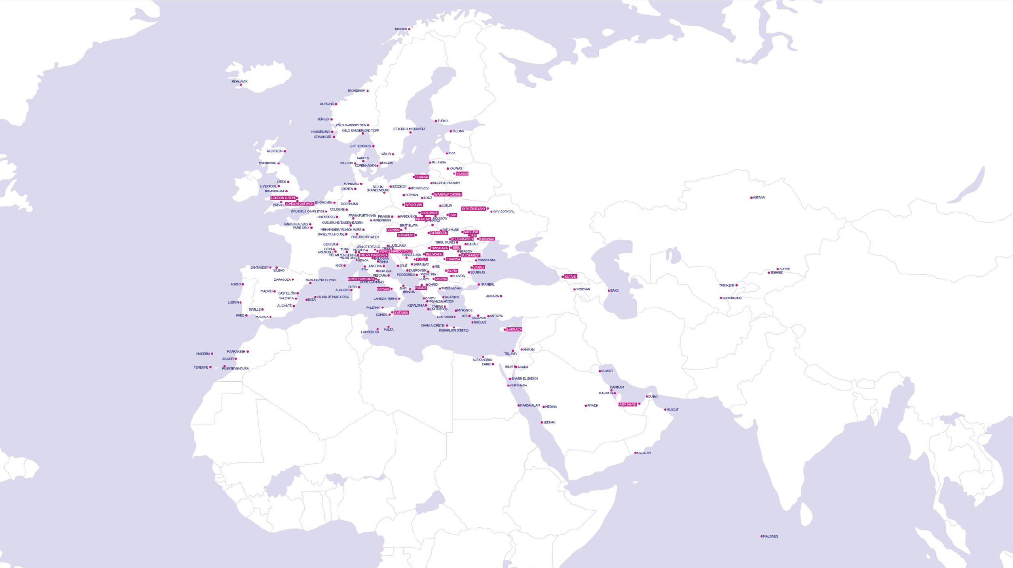
WIZZ BASES AND DESTINATIONS
7
950+ ROUTES TO 50+ COUNTRIES

WIZZ AIR IN NUMBERS
Sustained double digit passenger number growth in last 19 years (except COVID year)

NUMBER OF PASSENGERS
IN THE PAST 19 YEARS

Passengers
315 M

Aircraft

Airports Bases Employees Countries
183

194

32

8000+

54

COVID-19
impact

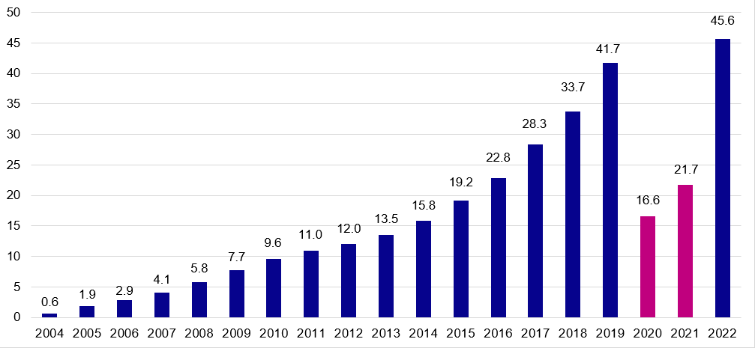

8

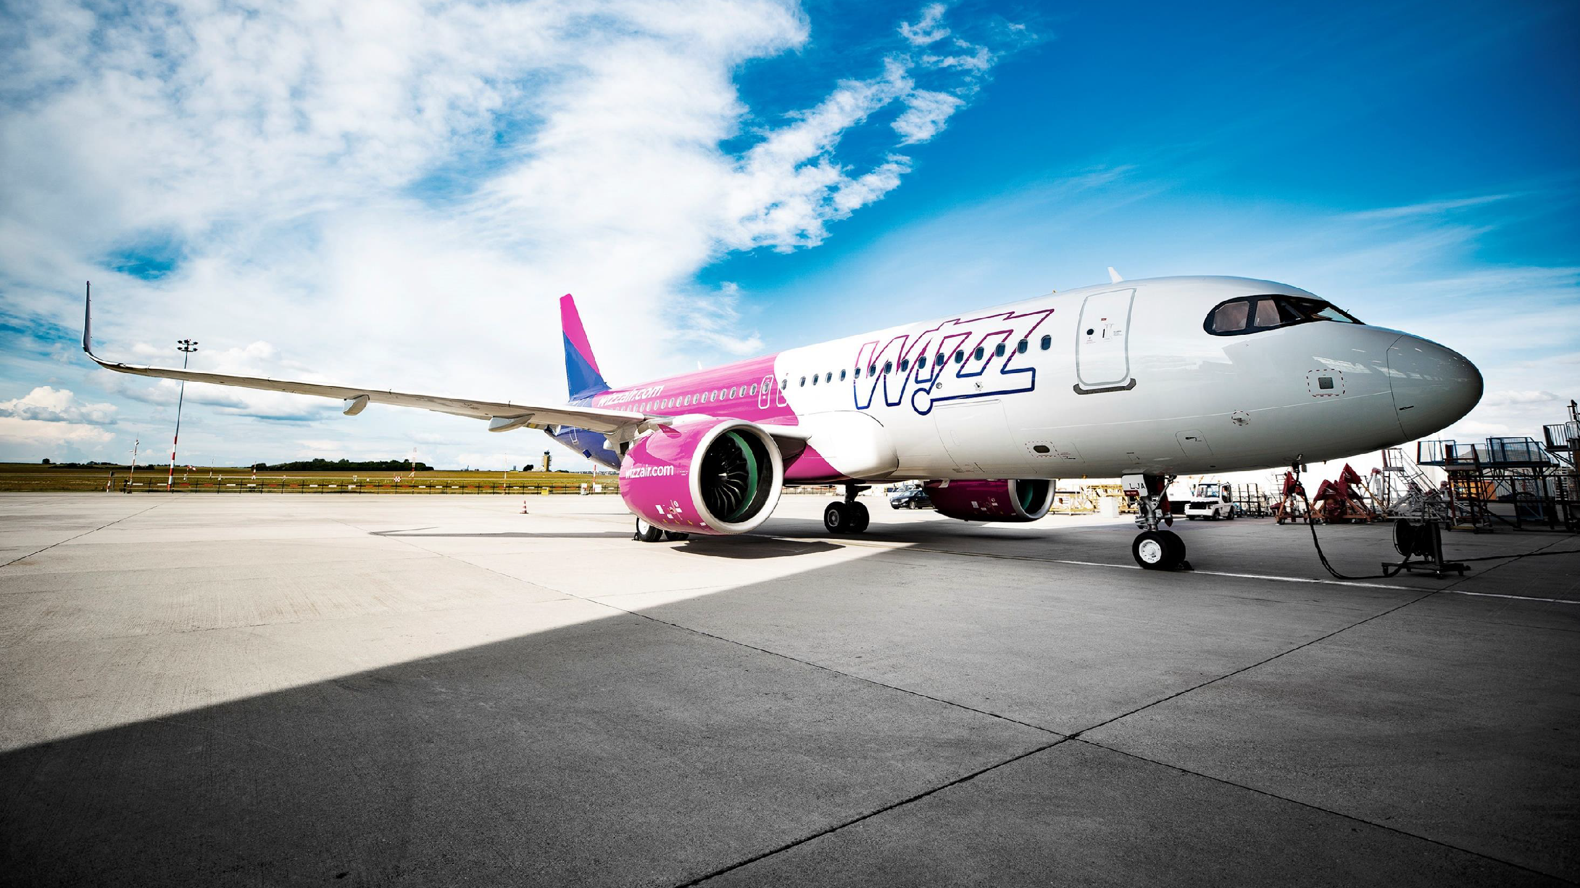
YOUNG AND EFFICIENT FLEET
9

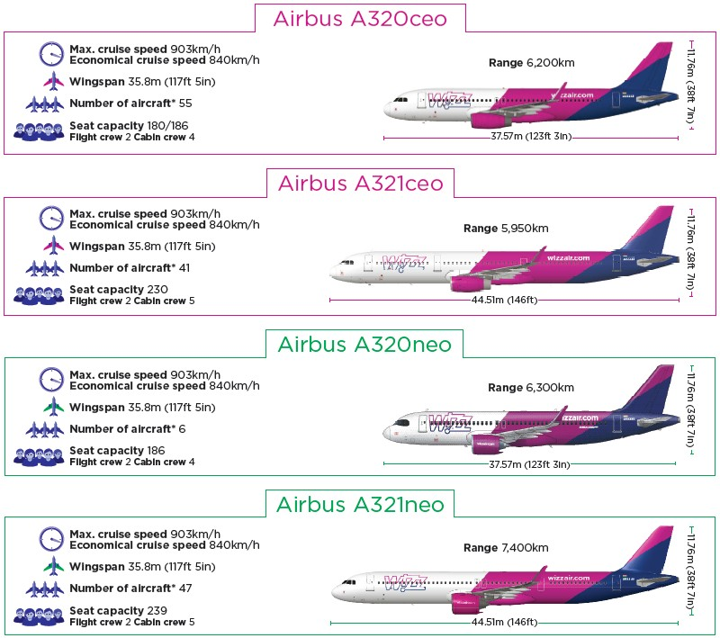
WIZZ AIR FLEET

AVERAGE AIRCRAFT AGE: 4.97 YEARS

POINT TO POINT TRAFFIC

+/- 30 MIN TURNAROUND TIMES

All new aircraft are delivered
with sharklets

10

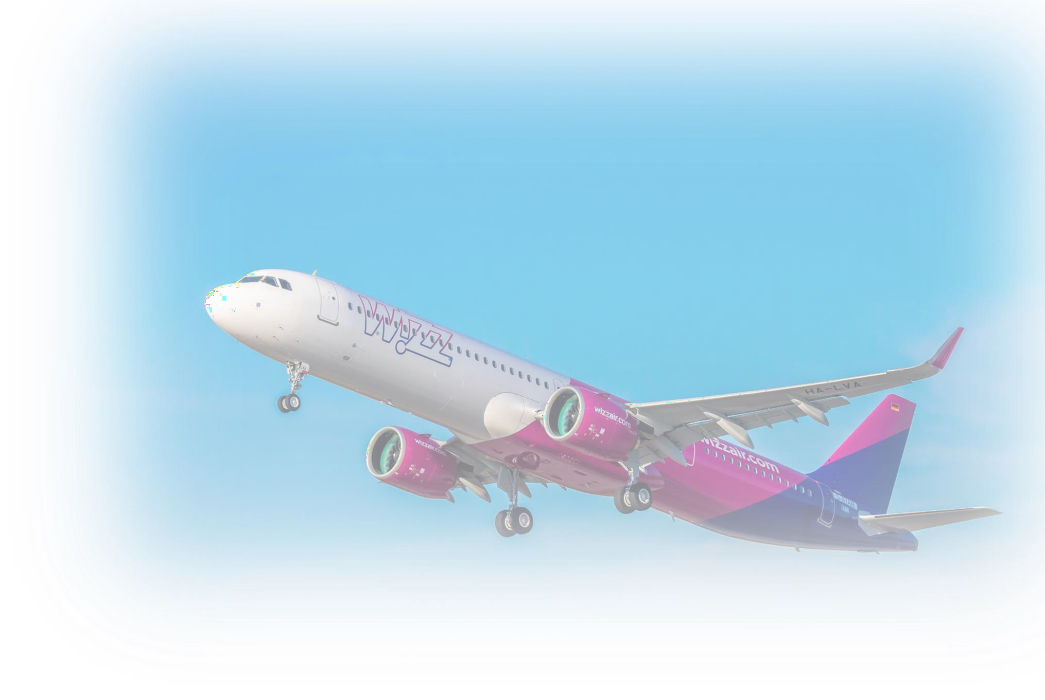

AIRBUS A321NEO AIRCRAFT
A GAME CHANGER

239
SEATS
20% LOWER
FUEL BURN
50% LOWER
NOISE EMMISION
50% LOWER
NOX EMMISION
LOWEST ENVIRONMENTAL FOOTPRINT
PER PASSENGER

11

SUSTAINABILITY | WIZZ AIR
12

WIZZ AIR EFFICIENT BUSINESS MODEL

EFFICIENCY

TECHNOLOGY

LOW EMISSION INTENSITY
CO₂

We don’t fly half-empty planes to avoid unnecessary pollution.
If every airline would be as efficient as us, European CO2 emissions from aviation would reduce by 34%.

We don’t have business class seating, another example of needless emissions.

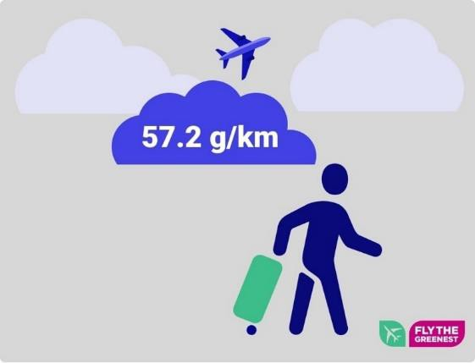
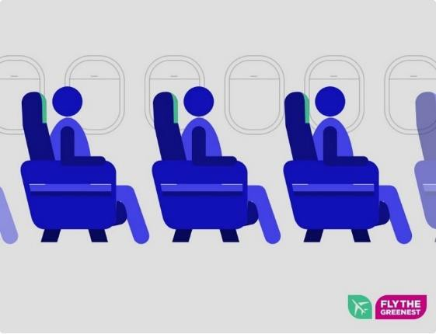
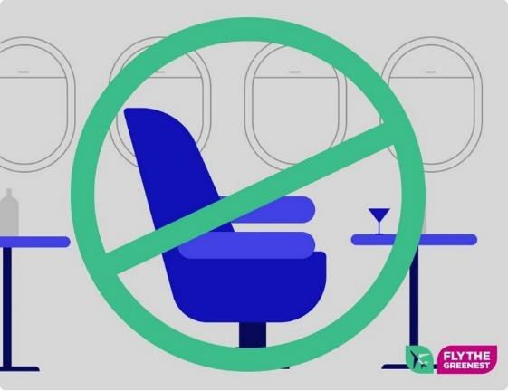
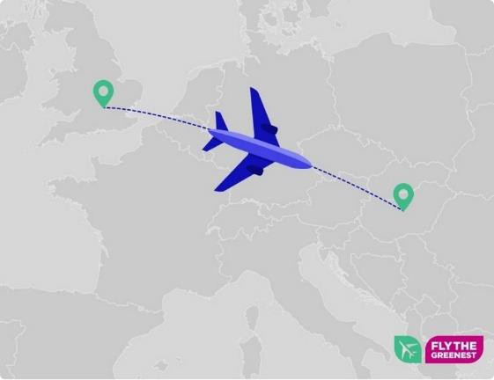
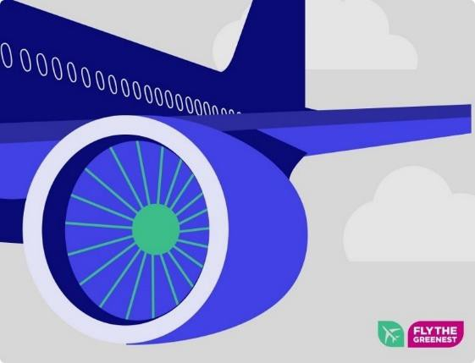
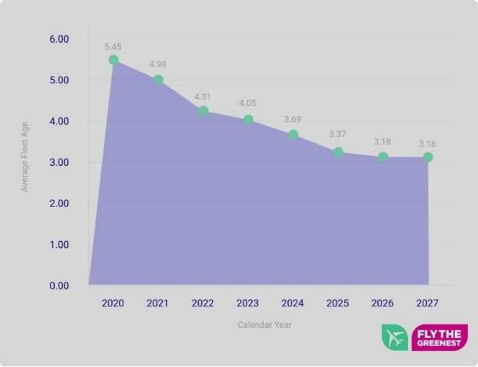
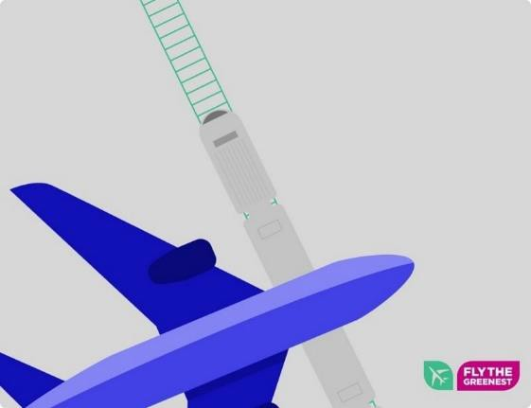
We only fly direct routes. One take-off, one landing, no
13 connecting flights, no extra
fuel-burn.
We use world-class engines and aircraft, crucial for low emissions.
We have the youngest, most modern fleet among European competitor airlines with 50+ aircraft.
Moreover, none of our routes have a direct train alternative under four hours.

BY THE END OF THE DECADE…
170M+

500

PAX/YEAR

20 000
EMPLOYEES

1
RECRUIT/HOUR
AIRCRAFT

2000
NEW HIRES/YEAR

1.6B
WEB VISITORS/YEAR

15B €
IN SALES/YEAR
1M
FLIGHTS/YEAR

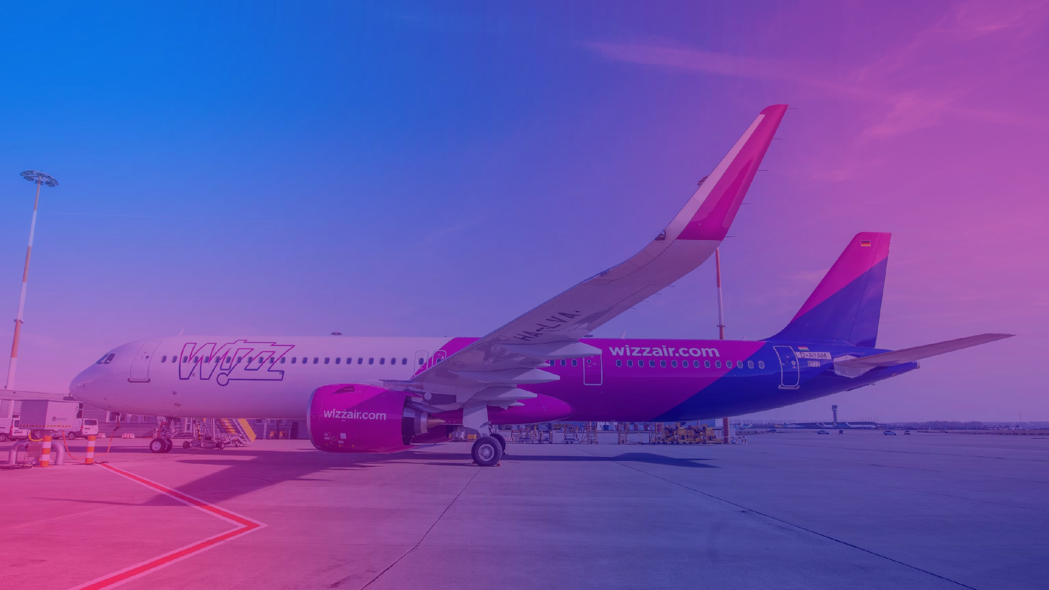

15

PILOTS SUITABILITY TO AOC

WIZZ AIR HUNGARY/ WIZZ AIR MALTA &
SUBSIDIARIES
ALL OTHER BASES
EACH CANDIDATE TO BE ASSESSED INDIVIDUALLY FOR AOC SUITABILITY
 Individual preference
 Unrestricted right to live and work in the EU or Albania, Bosnia and Herzegovina, Georgia, Moldova, North Macedonia, Serbia
 Valid EASA license or ICAO license for TR DEC
 Valid EASA medical certificate or ICAO for TR DEC
 Flying experience limitations

16

CONTRACTING – FOR WAH/WMT

SERVICE PROVIDER (CONFAIR)
 Available in most of the bases for pilots not based in their home country, on pilot request
 Paid holiday entitlements on contract:
- 24 days per calendar year
 Personal Income Tax:
- Pilots are required to report their taxes on their own discretion, based on their individual tax positions
 Social Security Contribution:
- Pilots are required to arrange social coverage for themselves
- To be paid as per the workplace of the pilot, can be requested to pay in home country
- Sick-leave coverage limited 5 days / calendar
year

LOCAL CONTRACT (WIZZ AIR)
 Local pilots based at home country can only go on local contract
 In the following countries only local contract is available:
Italy, Albania, Bosnia and Herzegovina, North-Macedonia
 Paid holiday entitlements on local contract:
- Defined by the governing Labour Code
 Personal Income Tax:
- All deducted and paid
 Social Security Contribution:
- All contribution are deducted and paid according to the local legislation
- Includes pension and healthcare
- Sick-leave period is covered

17

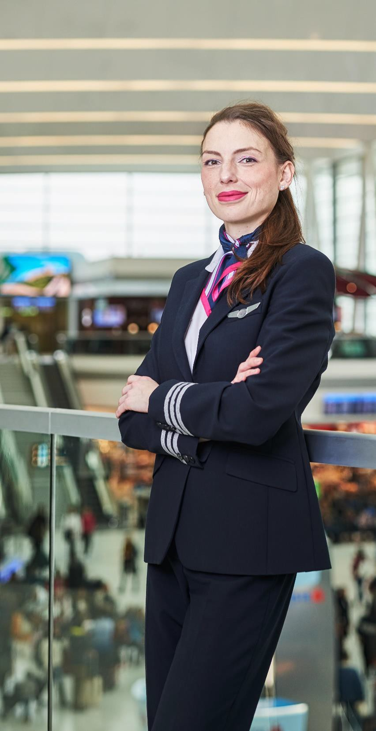
DC1-Internal Data

SALARY SETUP
ELEMENTS OF THE SALARY
Fixed base salary
Variable pay as per (i) flown km and (ii) performed landings
Other performance related pay elements

DEDUCTIONS
Local and/or Hungarian/Maltese tax
Local contributions

SALARY CALCULATION
4
OTHER PERFORMANCE RELATED PAY ELEMENTS
5
LANDING PAY
DISTANCE PAY
COUNTRY MULTIPLIER

1
BASE
SALARY
2
3
* Country multiplier applies to Wizz Air Hungary/Wizz AIr Malta only for pilots being on local contract and Confair pilots in KUT and KIV bases

DC1-Internal Data

SALARY CALCULATION
WAH AND WAM
POSITION | ANNUAL GROSS BASE SALARY
First Officer | 21,000 EUR
Senior First Officer | 26,000 EUR
CPT Below 1,000 | 45,000 EUR
CPT Above 1,000 | 49,000 EUR
CPT Above 2,000 | 53,000 EUR
CPT Above 3,000 | 57,000 EUR
CPT Above 4,000 | 61,000 EUR
CPT Above 5,000 | 65,000 EUR
CPT Above 6,000 | 69,000 EUR
CPT Above 8,000 | 73,000 EUR
CPT Above 10,000 | 77,000 EUR
CPT Above 12,000 | 81,000 EUR

BASE SALARY
DISTANCE PAY
LANDING
PAY
OTHER PERFORMANCE RELATED PAY ELEMENTS

20

VARIABLE SALARY RATES

OTHER PERFORMANCE RELATED PAY ELEMENTS
DISTANCE PAY
BASE SALARY
LANDING PAY
COUNTRY
MULTIPLIER

 | DISTANCE PAY |  | LANDING PAY*
 | WAH | WAM | WAH | WAM
First Officer | 0.0220 EUR/km | 0.0220 EUR/km | 12 EUR/landing | 12 EUR/landing
Senior First  Officer | 0.0431 EUR/km | 0.0429 EUR/km | 21.57 EUR/landing | 21.47 EUR/landing
Captain | 0.0772 EUR/km | 0.0769 EUR/km | 37.35 EUR/landing | 37.20 EUR/landing

* In countries where per diem is calculated based on local regulations (Bulgaria, Lithuania, North-Macedonia, Serbia), per diem is considered as the tax free part of the landing pay

21

ADDITIONAL ELEMENTS
BASE
SALARY
DISTANCE PAY
LANDING PAY
OTHER PERFORMANCE RELATED PAY ELEMENTS
COUNTRY
MULTIPLIER

 | First Officer |  | Senior First Officer |  | Captain
 | WAH | WAM | WAH | WAM | WAH | WAM
Office duty (daily) | 150-200 EUR | 150-200 EUR | 150-200 EUR | 150-200 EUR | 150-600 EUR | 150-600 EUR
Flying from OFF day/ vacation day | 120 EUR | 120 EUR | 200 EUR | 200 EUR | 300 EUR | 300 EUR
Out of base flying  (per positioning) | 30 EUR | 30 EUR | 50 EUR | 50 EUR | 100 EUR | 100 EUR
Flexible roster allowance | 400 EUR | 400 EUR | 400 EUR | 400 EUR | 600 EUR | 600 EUR
Line training compensation for trainers (per sector) | N/A | N/A | N/A | N/A | 40 EUR | 40 EUR

DC1-Internal Data

COUNTRY MULTIPLIER
BASE
SALARY
DISTANCE PAY
LANDING PAY
ADDITIONAL ELEMENTS
COUNTRY
MULTIPLIER

Country multiplier:
Country Multiplier
AUSTRIA | 1.25
BULGARIA | 0.90*
GEORGIA | 1.10
HUNGARY and AGENCY | 1.0
LITHUANIA | 1.19
MACEDONIA | 1.45
MOLDOVA | 1.10
POLAND | 1.05
ROMANIA | 1.45
SERBIA | 1.10
CYPRUS for CPT | 1.10
CYPRUS for S/FO | 1.07
ALBANIA | 1.05
ITALY | 1.27

- Applies for Wizz Air Hungary/Wizz Air Malta and Confair pilots based in KUT and KIV bases

- Applied on base salary, distance pay, landing pay and other performance related pay elements after flight check release

- Compensates for cost-of-living differences/certain taxation and SSC specialties

* Only applied to Landing Pay and Distance Pay
23

TAX & CONTRIBUTIONS
To the attention of those who choose local employment contract

Wizz Air Hungary Ltd Wizz Air Malta Ltd
Personal income tax:
- Double tax treaties between Hungary and the country of base is applicable
- In Hungary the personal income tax is 15% (flat rate)

Social security contributions:
- Are withheld according to the local regulations of the country of base

Bosnia and Herzegovina, Bulgaria, Cyprus, Georgia, Hungary, Lithuania, North Macedonia, Poland, and Serbia
Personal income tax:
- Double tax treaties between Malta and the country of base are applicable

Social security contributions:
- Are withheld according to the local regulations of the country of base

Albania, Austria, Italy and Romania

In countries where both Hungarian and local tax are withheld during the year, Wizz Air is supporting the tax reclaim process
24

WIZZ AIR HUNGARY LTD

Double tax treaty matrix

Country | Taxation method | HUN tax  rate | Local tax rate | Comments
Bosnia | Exemption based | 15% | n/a | only HUN tax will be withheld during the year
Bulgaria | Exemption based | 15% | n/a | only HUN tax will be withheld during the year
Cyprus | Credit based | 15% | 0%: until EUR 19.500  20%: EUR 19.501 – EUR 28.000  25%: EUR 28.001 - EUR 36.300  30%: EUR 36.301 - EUR 60.000  35%: over EUR 60.000 | both HUN and Local PIT will be withheld during the year
Georgia | Credit based | 15% | 20% | both HUN and Local PIT will be withheld during the year
Lithuania | Exemption based | 15% | n/a | only HUN tax will be withheld during the year
Moldova | Credit based | 15% | 12% | both HUN and Local PIT will be withheld during the year
North  Macedonia | Credit based | 15% | 10% | both HUN and Local PIT will be withheld during the year
Poland | Exemption based | 15% | n/a | only HUN tax will be withheld during the year
Serbia | Credit based | 15% | 10% | both HUN and Local PIT will be withheld during the year

In countries where both Hungarian and local tax are withheld during the year, Wizz Air is supporting the tax reclaim process

25

WIZZ AIR MALTA LTD

Double tax treaty matrix

Country | Taxation method | Maltese tax rate | Local tax rate | Comments
Albania | Exemption based | 0% | n/a | only MLT tax will be withheld during the year
Austria | Exemption based | 0% | n/a | only MLT tax will be withheld during the year
Italy | Credit based | 0% | 23%: EUR 0 – EUR 15.000  25%: EUR 15.001 - EUR 28.000  35%: EUR 28.001 - EUR 50.000  43%: over EUR 50.001 | Both Local and MLT PIT will be withheld during the year
Romania | Exemption based | 0% | n/a | only MLT tax will be withheld during the year

Employee is subject to 0% tax rate if he/she is spending not more than 183 days in Malta within a year

26

TRAINING BOND FOR NEW JOINER PILOTS - CURRENT

 | COMPANY SPONSERED ATP | COMPANY SPONSERED TYPE RATING | DIRECT ENTRY COMMAND PROGRAM BOND
TOTAL COST | 35 000 EUR | 30 000 EUR | 10 000 EUR
BOND AMOUNT | 20 000 EUR | 15 000 EUR | 10 000 EUR
BOND DURATION | 48 MONTHS | 36 MONTHS | 20 MONTHS
BOND  DEDUCTION | 415 EUR / MONTH | 415 EUR / MONTH | 500 EUR / MONTH
BOND BONUS | 10 000 EUR | 7 500 EUR | 5 000 EUR
* The above deductions are build into the salaries, converted to local currency where applicable

DC1-Internal Data

WIZZ AIR HUNGARY / WIZZ AIR MALTA
SIGN UP AND BASE SPECIFIC RETENTION BONUS

 | ONE TIME GROSS AMOUNT PAYMENT – ONLY FOR WAH/WMT
 | FIRST OFFICER | SENIOR FIRST OFFICER | CAPTAIN
SIGN ON BONUS | 5.000 EUR | 5.000 EUR | 10.000 EUR
3 YEARS RETENTION | 25.000 EUR | 25.000 EUR | 40.000 EUR
PROLONGED OUT OF BASE | 30 EUR / DAY | 50 EUR / DAY | 100 EUR / DAY

After three consecutive years or more (for FO & SFO - sign-on bonus of 5,000 EUR, loyalty bonus 25,000 EUR and for CPT, sign-on bonus of 10,000 EUR and loyalty bonus of 40,000 EUR).
The program will be available at specific bases which will be reviewed on a yearly basis. This year, the loyalty bonus will be available in Craiova, Suceava, Iasi, Skopje and Kutaisi.

DC1-Internal Data

DC1-Internal Data

PATTERN CHANGES

Pattern type | Position | Comment
5/4 | FD | To replace current 6ON 4OFF pattern from 8th January. Will be scheduled as 5ON +  1REST + 3 OFF to accommodate afternoon duties on last ON day.  From 2024 only one selected peak month (JUL-AUG or Xmas) to be counted as flexible.
14/7 | FD | To be extended and rolled out to other bases as well from October 2023. From 2024 only one selected peak month (JUL-AUG or Xmas) to be counted as flexible.
15/15 | FD | Available in 3 bases (TIA, IAS, and KUT) as per rules in policy.
Flexible pattern  (with compensation) | FD | Remains as today. In bases where fixed 14/7 is available there will be no possibility  for “flexible commuting pattern”
Reverse pattern | FD | As per the “Reverse roster policy”

30

TIMELINE

JUL- AUG
SEP OCT NOV DEC JAN FEB-
DEC24

100% flexible for FD as per the old plan
Returning to old patterns per old plan
Starting 14/7 in CRA
and SCV
Pattern continues

100% flexible for FD
as per the old plan
5/4 starts as per new plan
Crew selects one of the 3 months for flexible pattern (JUL- AUG or Xmas)

31

ADDITIONAL OPPORTUNITIES:

3.
Floating Romania (limited slots)

DC1-Internal Data

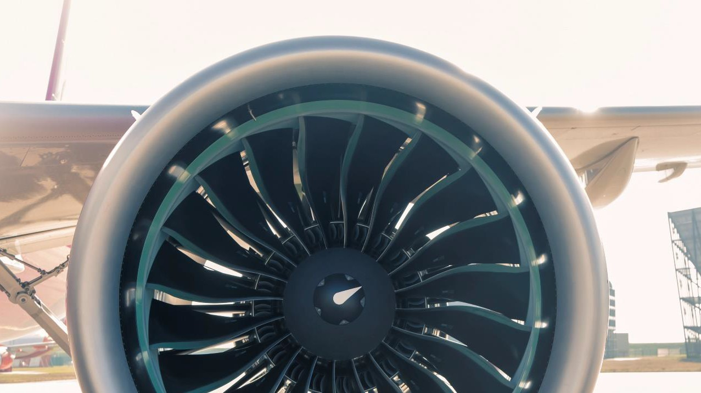
BASE ALLOCATION & BASE CHANGE POLICY
 Allocation: As per the operational needs considering individual preference
 Waiting List: Base change waiting lists are updated permanently
 Change policy: As per transparent – First Come, First Serve type Base Change Policy

CPT FO
DC1-Internal Data
AUH
BEG
BUD
CTA
DEB
FCO
GDN
IEV
KRK
KTW
LCA
LGW
LTN
MXP
OTP
SBZ
SKP
SOF
TSR
VAR
VCE
VIE
VNO
WAW
WRO

OTHER BENEFITS 1.
DC1-Internal Data

OTHER BENEFITS 2.
DC1-Internal Data

COLLABORATIVE COMMUNITY SPIRIT
DC1-Internal Data

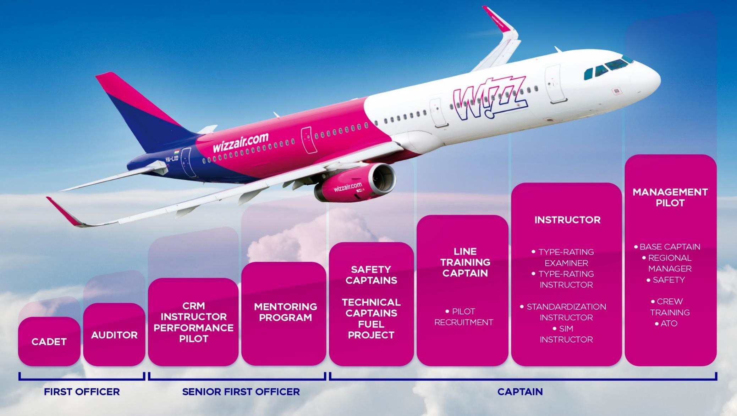
CAREER STEPS AND UPGRADE
DC1-Internal Data
Additional roles can increase earning potential and provides a good opportunity to take the next step in your career.

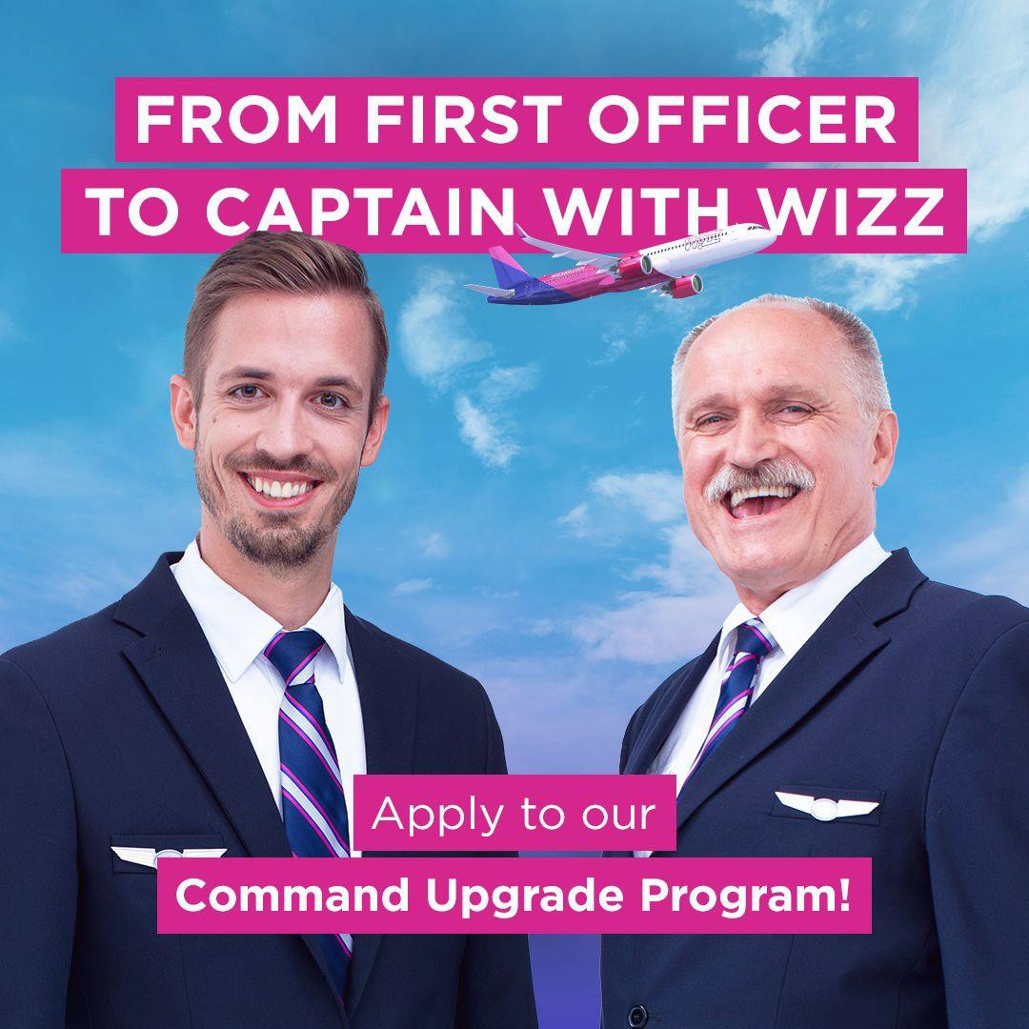
a

Designed for Airbus experienced pilots joining Wizz Air directly on a commander
contract who will undergo an extensive Command Upgrade Program before released as a Captain across our network:

- Unrestricted right to live and work in the EU or Albania, Bosnia and Herzegovina, Georgia, Moldova, North Macedonia, Serbia
- Valid EASA Airline Transport Pilot License (ATPL)
- Valid Class 1 Medical Certificate
- Valid Instrument Rating (IR) on Airbus A320*
- ICAO level 4/5/6 English proficiency
- Minimum 3.500 factorized hours**
- Minimum 300 hours actual flight time on on Airbus A320/A330/A340/A350/A380 (in combination) in the last 12 months***
- Minimum 3.000 hours actual flight time AND 100 landings completed on Airbus A320/A330/A340/A350/A380 (in combination)
DC1-Internal Dat

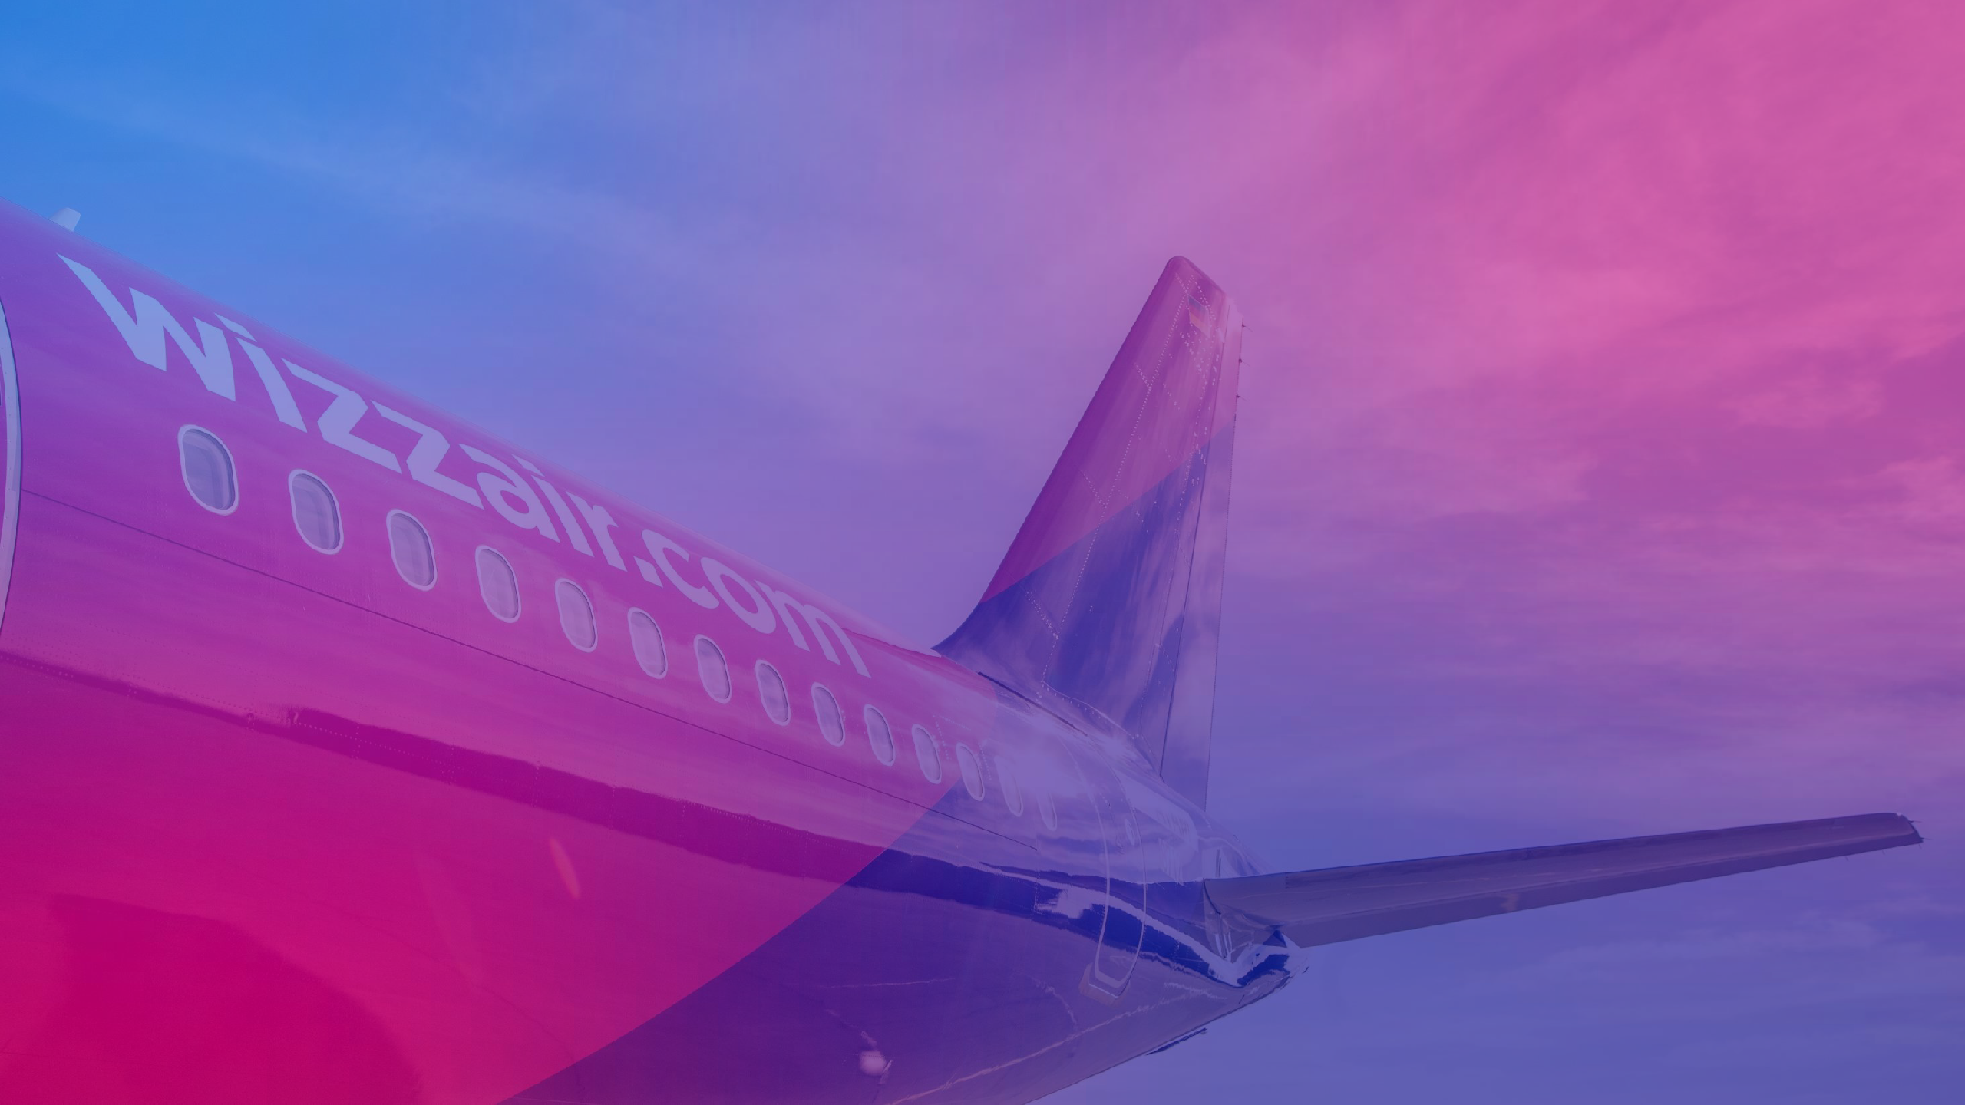

APPLICATION & RECRUITMENT

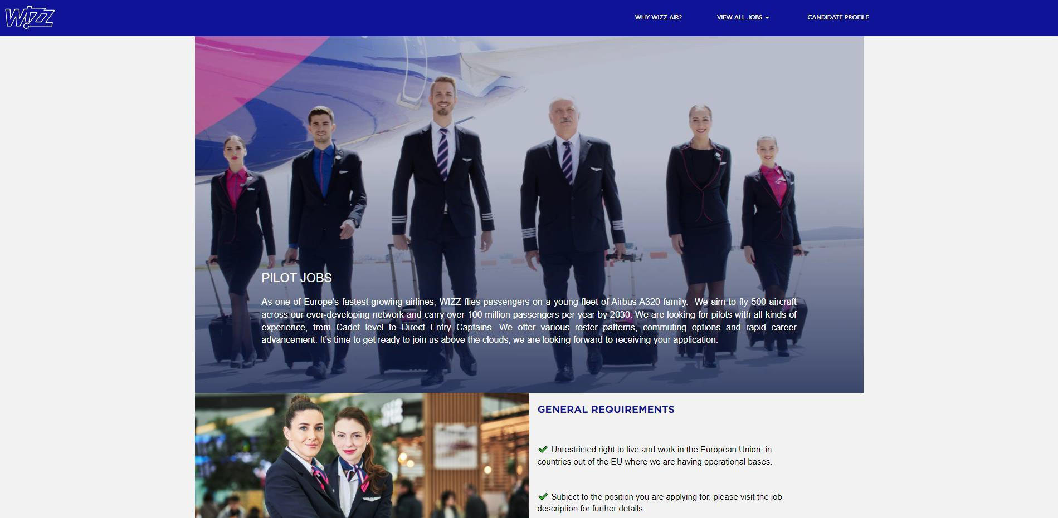
HOW TO APPLY
DC1-Internal Data

careers.wizzair.com

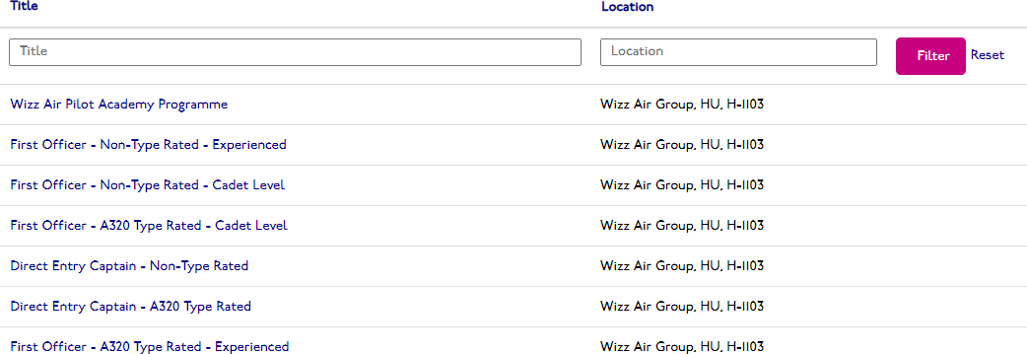
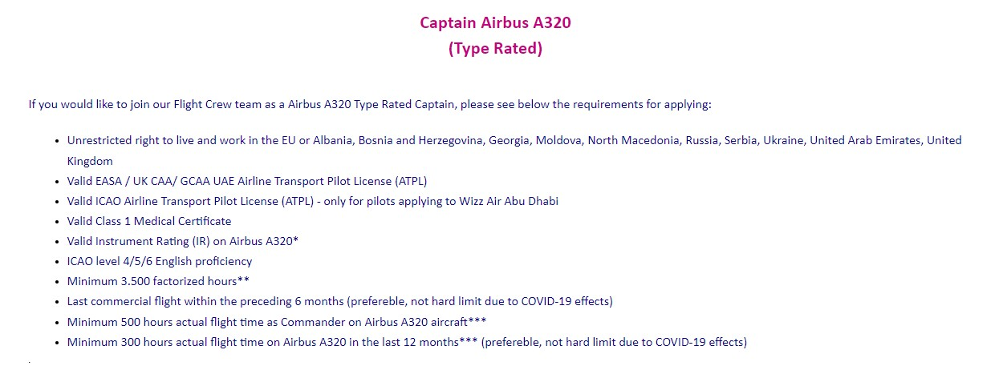
CRITERIA FOR A SUCCESSFUL APPLICATION
careers.wizzair.com

  - Before applying, please always x-check if you meet all the criteria of the exact position.
  - If you do not meet all criteria, please find another open position.
  - If your application is not selected, please check which criteria you didn’t meet and try to find another open position.

DC1-Internal Data

RECRUITMENT PROCESS

New Application
Offer Onboarding

Primary
Screening
Holding Pool
Contacting

Secondary Screening
Assessment
Start of the Employement

42

TRAINING CENTRE
Budapest

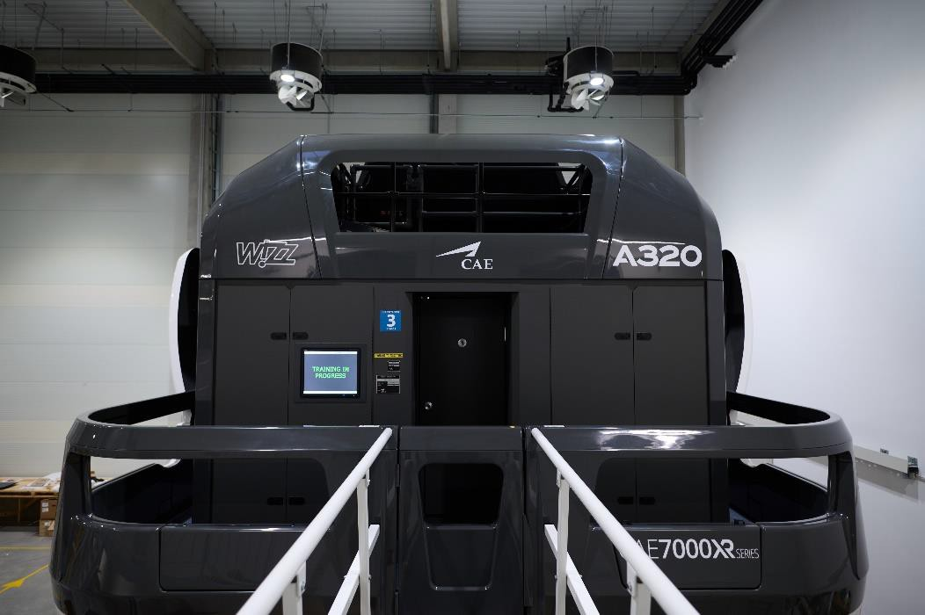
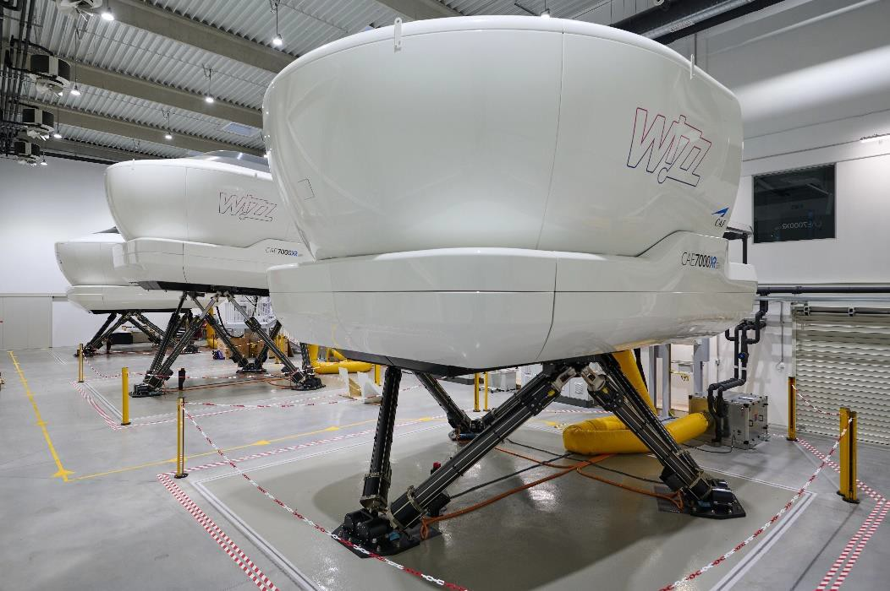
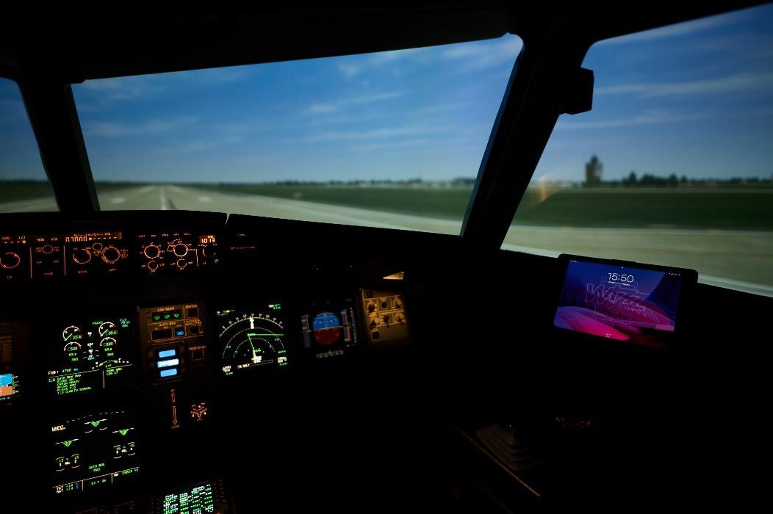
DC1-Internal Data

DAY 1 DAY 2

Company
Presentation
Documentation Check
Stage One
Pilot Technical Test
Group Exercise
Pilot Technical
Interview
Personal HR Interview
Stage Two
Simulator
Evaluation
Stage Three
Psychometric
Test
Stage Four

EACH STAGE IS SUBJECT TO SUCCESSFUL COMPLETION OF THE PREVIOUS STAGE

44

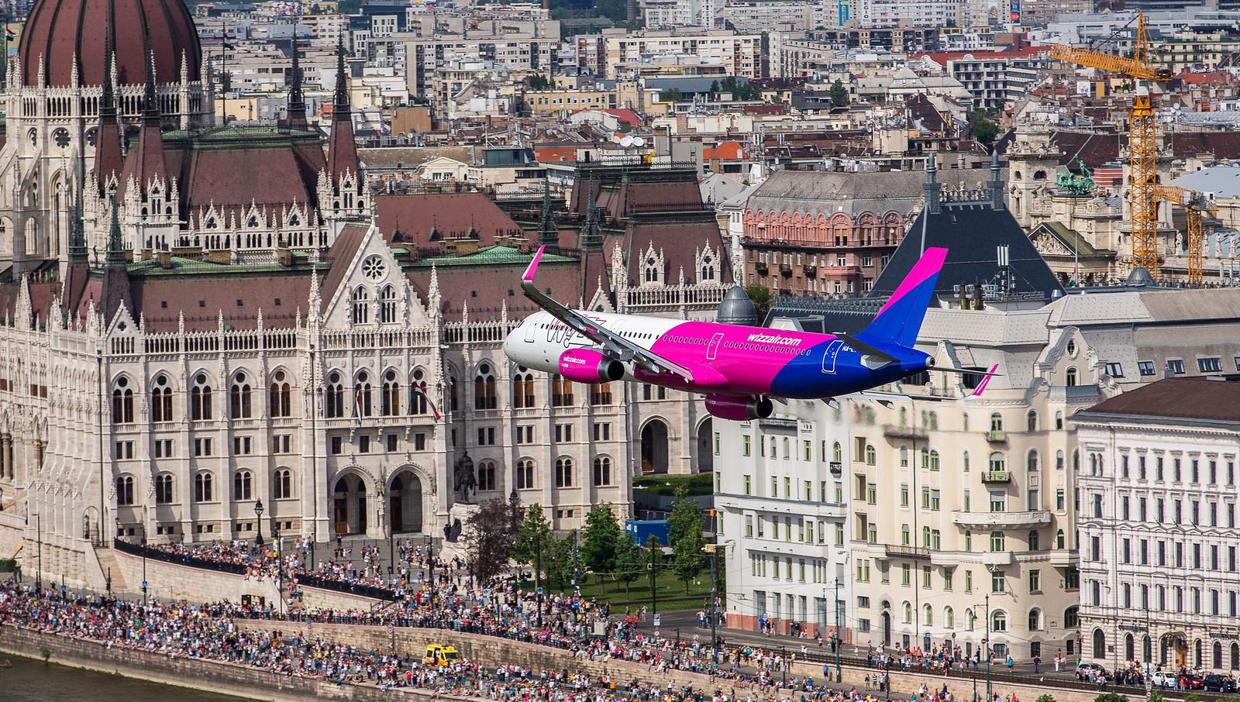
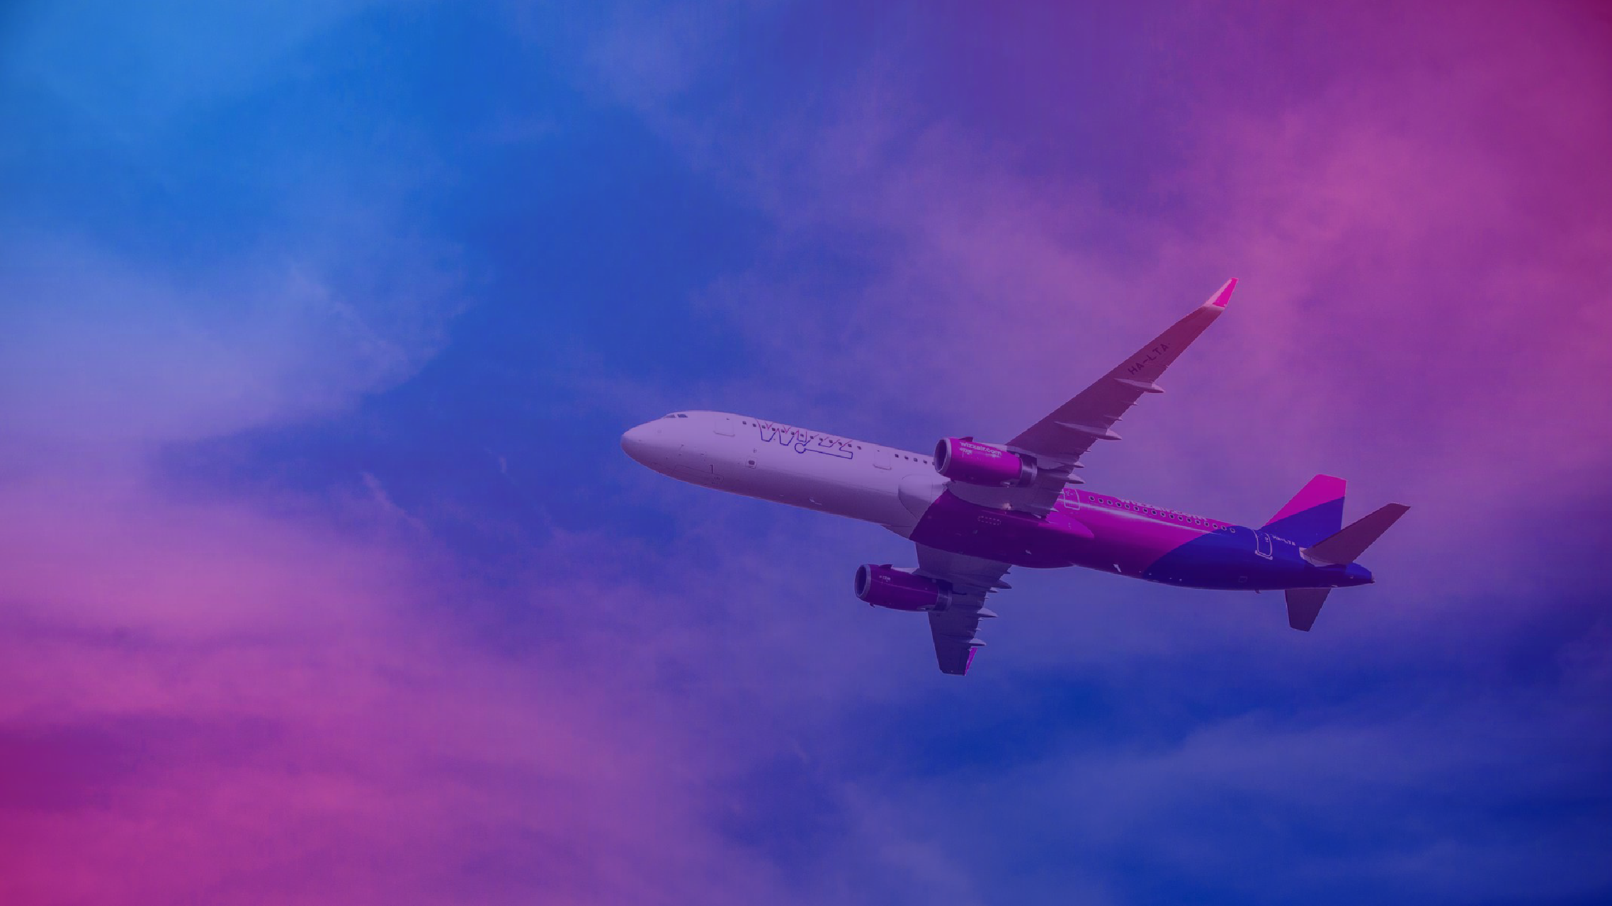

THANK YOU

45

